

Asia Pacific College

School of Computer and Information Technology

Magallanes, Makati City

**UNITY HOUSEKEEPING SYSTEM**

**Mr. Neal Rumbaoa**

(Client)

Submitted by

Project Manager - John Ryan L. Garcia

Project Developer - Earl Peter O. Gonzaga

Documentation - Jimmy M. Famador Jr

Project Developer - Tyronne Joshua U. Betita

Submitted to

Ms. Maricel P. Naviamos

(Professor)

July 19, 2017

Title Page

Table of Contents ………………………………………………………….. i

List of Tables

5.7 Proposed Data Dictionary

5.2 Tables/Files Layout

5.3 Use Case Narrative Report

List of Figures

5.1 Proposed Data Flow Diagram

5.3 Use Case Diagram

5.4 Entity-Relationship Diagram

5.3.5.1Activity Diagram – Login

5.3.5.2 Activity Diagram – Create task list

5.3.5.3 Activity Diagram – Scan QR code

5.3.5.4 Activity Diagram – Update check list

5.3.5.5 Activity Diagram – Double check data

List of Appendices

1. Introduction ……..……………………………………………………… 1
   1. Project Context.………………………………………… …….... 1
   2. Purpose and Description ……………………………………….. 2
   3. Statement of Objectives ……………………………….………. 3
      1. General Objectives……………………………….… 3
      2. Specific Objectives……………………………….… 3
   4. Scope and Limitations of the Study ……………………………. 3
2. Review of Related Literatures/Systems……………………………….... 4
3. Technical Background………………………………………………….. 28
   1. Programming Language………………………………………… 28
      1. Back End Network…………………………………. 29
   2. Resource Requirements…………………………………………. 30
      1. Hardware& Software Requirements……..……….… 30
4. The Existing System……………………………………………………. 31
   1. Company Background…………………………………………... 31
   2. Description of the System………………………………………. 31
5. The Proposed System…………………………………………………… 32
   1. Process Specification…………………………………………… 32
      1. Data Flow Diagram…………………………………. 32
      2. Data Dictionary……………………………………... 32
   2. Data Specification………………………………………………. 33
      1. Proposed Conceptual Framework…………………,... 38
      2. Use Case Diagram…………………………………… 39
      3. Entity-Relationship Diagram………………………... 46
      4. Tables/Files Layout…………………………………. 47
   3. Other Diagrams………………………………………………,…. 42
      1. Use Case Narrative Report…………………………... 40
      2. Activity Diagram…………………………………….. 43
      3. Gap Analysis……………………………………….… 48
      4. Gantt Chart……………………………….................... 49

**Chapter I**

**Introduction**

# **Introduction**

In 1939, Taal Vista Hotel was constructed by the Zamoras who owns the Manila hotel. Taal Vista has many accommodations where the hotel promotes different kinds of rooms. Taal Vista has a schedule of activities like Traditional Folkloric dance where the hotel let guests to experience the wonders of our cultural heritage and Weekend Market where the hotel let the guests enjoy Tagaytay-grown fruits. Lastly the hotel let the guests relax and enjoy the hotel’s outdoor swimming pool and spa services. We are being tasked to create a system for the hotel housekeeping management that keeps track of the housekeeping checklist in every single room.

## **1.1 Project Context**

Inside the hotel industry, Hotel management includes many concepts like food service, servicing guests, etc. Housekeeping management takes care of and accommodates the needs of every guest in the hotel. Housekeepers clean the hotel rooms and maintain a clean environment for their guests. They do this in order to achieve a satisfactory rating from customers. Currently, the housekeeping management has identified some problems that affect their service quality. These problems are slow housekeeping service and human errors. With the help of a housekeeping system, the Housekeeping Management can minimize the occurrence of these problems.

The proposed system will require QR codes in every hotel room. These QR codes will contain the hotel room number, status and task list depending on the type of the room. The housekeeper will update their status using the application to record their “time in” and “time out” of their task. The housekeeper will also record the tasks completed in the task list that is part of the system.

After the housekeeper cleans the rooms assigned to him/her, the housekeeping supervisor will inspect each room that has been cleaned. This system aims to support the hotel staffs in doing the housekeeping chores and checks the room for the final requirement.

# **1.2 Purpose and Description**

Unity Housekeeping System’s purpose is mainly to help staffs and guests with an easy and a user-friendly Housekeeping System application with hotel staffs’ task management, problem reports, suggestions on improving the hotel housekeeping management, and room checking. The supervisor will be assigning the housekeeper to clean the room and the supervisor will check each room that the housekeeper organized.

Another purpose of the application or system is to help housekeeping staff to be more productive because of the easy to use system. It also has a hotel room cleaning module that has a complete process on how the housekeeping management does the cleaning of each hotel rooms.

# **1.3 Statement of Objectives**

## **1.3.1 General Objectives:**

The general objective of the team in building the Unity Housekeeping System application is to develop a system or application that will help SM Hotel’s housekeeping management and staff to do tasks in an easy, efficient, and more productive way. Unity Housekeeping System includes a module that will complete the application in helping SM Hotel’s housekeeping management.

## **1.3.2 Specific Objectives:**

Hotel Room Cleaning Module that includes checking and cleaning in housekeeping management. The module also includes the checking of each room in the hotel. The Unity housekeeping system mainly revolves in the cleaning and checking of each hotel room and the Hotel Room Cleaning Module is what gets the job done.

# **1.4 Scope and Limitations**

The scope of the system will be focusing primarily for the housekeeping management of a hotel. The system will also concentrate on hotel management’s performance through the checking process and room cleaning maintenance. The housekeeping system is assigned to add task(s) to a staff every time a housekeeper is done cleaning a room. Every housekeeper will be having an Android device (At least Ice Cream Sandwich) Operating system that can be used in each task.

**Chapter II**

**Review of Related Literature/Systems**

# **2.0 Review of Related Systems**

## **2.1 Existing Systems:**

**HOTELOGIX**

By definition, housekeeping is the general care, orderliness, and maintenance of business or property. However, in the article “Defining Housekeeping”, housekeeping refers to the management of duties and chores involved in the running of a household. This definition indicates the maintenance process in the business which offers hygiene and all ancillary support. There are several housekeeping systems in the internet, the HOTELOGIX have a good housekeeping system. According to my research the HOTELOGIX system can assign the task and lets you sustain your list of housekeeping staff with no breaking points and you can assign rooms based on blocks/floors or sort them based on their status to manage division of work. Then they go to the Task List, the daily list of housekeeping tasks is easy to print and work easy to divide and distribute amongst the staff. The work is made easier with tools to channel and sort rooms based on blocks and floors and their status. And when the rooms or floors encountered some problems the system also have room maintenance. You can get a simple task & messaging system for special requests. Maintenance and repair activities can be allocated by staff from same or other department. Specially, the system can automate changes in housekeeping status of the rooms and let the system change room to ‘Dirty’ on checkout, or a clean room to ‘Inspect’ on night audit. This features help reduce efforts on repetitive tasks and lessen the chance for errors. (Bhatnagar, B (2000) Property Management Simplified [online]. Available: <http://www.hotelogix.com/>. (March 2000)

**Virtual Resort Manager (VRM)**

The Virtual Resort Manager has taken the management system of housekeeping to a new level of ease and effectiveness. The system is centered on remarkable Housekeeping Scheduling Grid, which makes the scheduling, last minute changes of housekeeping charges directly to the vendor. Based from the site, from the grid the housekeepers which are assigned at the specific property level can be easily changed to fit changing conditions and workloads. The VRM is built as a single package with all functionality operating together as a single combined process and the benefit of this is the elimination of double tasks, increased speed of operation, and less chance of human error. And with VRM, the data of the customer is housed in discrete database with a redundant backup. This is a good scheme for the customer’s private information compared to the HOTELOGIX that only focuses on maintenance of the hotel. By having the possible security protection for the system, by always having most up to the minute backups available. (Wenk, P (2001) Virtual Resort Manager Housekeeping [online]. Available: <http://www.virtualresortmanager.com/housekeeping.asp>. (July 2017)

**KNOW Housekeeping**

Know housekeeping system there are sufficient features that can help the customers in a better way. First, the two way messaging for attendants and supervisor this feature set the communication from the customers, to the housekeepers and can elevate to supervisors to fix the issue. This scheme is important for the customer’s satisfaction to gratify their complaints in the room. Then the performance report, to monitor the complaints of the customers to the housekeeper of the hotel and to observe how well did they do. And Move around tracking, for real time tracking of cleaning progress and reduction of inspection time and focus on quality maintenance. This system is efficient compared to the previous systems that I’ve researched. This strategy can improve the housekeeping performance of the hotel. (2002, KNOW Housekeeping [online]. Available: <http://www.knowcross.com/know-housekeeping/>. (July 2017)

**FCS E-HOUSEKEEPING**

The FCS-Housekeeping Operation Management, it streamlines housekeeping operation with automated room assignment, proper inspection and management functionality. For the room, inspection and productivity matrices you can track all task progress and rest assured that no assignments fall off the radar. For uniqueness of the system they have a m-housekeeping, that can guarantee faster response times using mobile technology. With m-Housekeeping the IOS and Android is compatible for their application, so that the staff can access the full capabilities of e-Housekeeping wherever they may be. Housekeeping teams can update the status of cleaning and inspection assignments instantly, as well as carry out daily duties with just a touch of their fingertip. The software records every item in a better and systematic way that reduces the human effort. This allows the housekeeping to focus on the more productive work in a hotel like hygiene and cleanliness. This is the most unique system, because of their e-Housekeeping system that efficiently do the task easier and faster. (2008, Modern Housekeeping [online]. Available: <https://www.fcscs.com/e-housekeeping/?gclid=Cj0KCQjw7pHLBRDqARIsAFyKPa6JKWDnUgIUx_L7fGi-sl5hsjthBc1HZBWKNET6DOtMFbfj5nAOMgIaAhLxEALw_wcB>. (July 2017)

**Opti Keeper**

Optii Keeper is a hotel housekeeping software that is available in the market that is used by many hotels today. It is timely and professional housekeeping management that aims a goal for better guest experience and successful hotel operation. Optii keeper is innovative patent labor management that maximizes capability and productivity throughout the housekeeping function. It enables you to view and control your housekeeping operations in real-time, delivering insights and benchmarks to help you streamline your performance. It also allows guests to access rooms faster and eliminates communication between reception and housekeeping and helping you focus on your customer. It is fully mobile, Completely multi-lingual and user friendly. Current housekeeping software solutions cannot make a distinction between the patterns. The software estimates cleaning times by checking the guest type then optimizes the housekeeping schedules in real-time. To improve this housekeeping software, the software must include staff assistance to improve the hotel management functions. (2011), The Optimum Housekeeping Solution [online]. Available: <http://optiisolutions.com/>. (July 2017)

**Winter Halter**

WinterHalter is a great service for a housekeeping system, because winterhalter can provide hygiene, reliability sustainability and performance not only for the staffs but also for the customers. Efficiency and user-friendliness are top priorities for Winterhalter. This is why they are constantly working to optimize our products, both in form and content. With its state-of-the-art formulas, the Winterhalter range of detergents and warewashing hygiene products even more effective and precise. The winterhalter washing chemicals assortment makes handling easier, also, it quickly provides an overview of the product and its field of use which will make it user friendly for the users. The Winterhalter also provides catering hygiene program and they can be tailor kitchens. Their products will effectively clean all the materials and equipment in the kitchen. Guaranteeing kitchen hygiene is Winterhalter’s top priority, they also have created a well-thought out, language-independent system. It quickly provides an overview of the product and its field of use. The products they produce are recycled and environmental friendly each product in the Winterhalter environmental range has been formulated to minimize the impact on the environment. They utilize raw materials from renewable resources, are fully biodegradable and use recycled and recyclable packaging. (Winterhalter, K. (1947) winterhalter Housekeeping [online]. Available: <http://www.winterhalter.biz/>. (July 2017)

**Starwood Hotel Housekeeping**

The Housekeeping department is typically the largest in the hotel in terms of both the number of associates and annual operating budget Starwood offers housekeeping and laundry for a system. Much of a guest’s overall impression of the hotel relates to its cleanliness; therefore, Housekeeping associates play a crucial role in ensuring an exceptional guest experience. Ideal Housekeeping and Laundry associates are extremely detail-oriented. They strive to provide guests with clean and comfortable accommodations while away from home. From fresh bed linens to spotless bathrooms and immaculate lobbies, our associates are committed to upholding Starwood’s quality and cleanliness standards at all times. Unlike Winterhalter, Starwood focuses on making the guests comfortable, while winter halter focuses on hygiene given to the customers or users. (Hohman, R. (2007) Starwood Hotel & Resorts [online]. Available:https://www.glassdoor.com/Hourly-Pay/Starwood-Hotels-and-Resorts-Housekeeping-Hourly-Pay-E335_D_KO28,40.htm. (July 2017)

**Housekeeping-5s**

This system is designed for the housekeeping operators and supervisors. The role of this system is to monitor the daily flow of housekeeping tasks and keeps track of the progress of housekeepers. It also allows the job to be easier than not having a system. Unity Housekeeping system can also relate Housekeeping-5s because the role of Housekeeping-5s is similar to what the Unity application has. (CRIG (2005) Factory Systems [online]. Available: <https://www.factorysystems.eu/index-en.php?id=5s-en>. (July 2017)

**Hospital Housekeeping Systems**

Hospital Housekeeping Systems is a system that will make sure that the patients or the guests in a hospital receives proper healthcare from the housekeeping management. The system also has a module that focuses on the housekeeping services, equipment and supplies, and the housekeeping staff. The Hospital Housekeeping Systems is related somehow to the Unity Housekeeping system because it focuses on the housekeeping services and staff. (1975), HHS Housekeeping [online] Available: <https://www.hhs1.com/>. (July 2017)

**Home Sanctuary**

The Home Sanctuary’s housekeeping system role is to provide a scheduling service for the housekeeping management. The system includes a time schedule that will have the schedule for each housekeeping task. The time schedule includes the day, the time, and the number of tasks to do in each day and time. In conclusion, Home Sanctuary is mainly a housekeeping system that kees track of the schedule of the housekeeping management. (Ridge. R (2012) Housekeeping Schedules [online]. Available: <http://www.homesanctuary.com/rachelanne/2011/09/housekeeping-schedules-and-daily-home-management.html>. (July 2017)

**LLC**

LLC focuses on the integrated facilities of a housekeeping management. The system focuses on a support service system for the housekeepers and its facility or management. It is a hospital housekeeping system that also focuses on healthcare. The system has a module that will store every tasks given to the housekeeping management. (Connerly. C (2003) Living Learning in Community [online]. Available: <http://legacy.earlham.edu/~kohlhe/blog/archives/000768.html>. (July 2017)

**RoomKeyPMS**

The RoomKeyPMS is a housekeeping management system, according to my research the RoomKeyPMS streamlines a housekeeping operation with personalized schedules that can help the cleaning staff and assigning their different tasks. Also, live status tracking, that can support the assign inspector to check each room in the hotel with live status tracking. The RoomKeyPMS, can easily add or alter attendants and their targets to guarantee uninterrupted service. (Khaled. D (2010) Room Key PMS [online]. Available: <http://support.roomkeypms.com/>. (July 2017)

**SNAP PMS**

What is SNAP PMS? SNAP PMS is an online hotel property management system, an all in one hotel reservation and property management system designed for all types of small properties. SNAP PMS have an efficient housekeeping system. The SNAP PMS has an Internet Booking Engine, that can instantly deliver the reservations. The snap booking engine is mobile-friendly the guests can book via desktop, tablet, or even smart phones. Also, the SNAP PMS has a Channel Manager, that can manage booking channels via one click. Lastly, it has a Housekeeping Module that can help the housekeeping helpdesk to track arrivals, departures, and housekeeping duties easily. (2009), Online Hotel Property Management System [online]. Available: <http://www.snappms.com/>. (July 2017)

**TrigernixHMS**

TigernixHMS offers housekeeping management module that gives a great line of features that can enable the staff to manage the hotel’s housekeeping processes. Housekeeping room attendants and their supervisors directly record task information in the Housekeeping Management module making the whole work process basic, smooth, and fast. The help desk can manage staff competently through scheduling, task-allocation and inspection features. The TrigernixHMS can also define job roles and responsibilities, and assign specific tasks with required instructions to carry out the task. With housekeeping module, tasks can be overseen well in a convenient way, sticking to guidelines, fulfilling sanitation requirements of the Hotels Act. (2006), Hotel Management System [online]. Available: <https://www.tigernix.com/home/software/hotel-management-system>. (July 2017)

**Inspect2GO**

According to my research, several housekeeping system has the same modules that streamlines cleaning and other housekeeping tasks. But Inspect2GO hotel housekeeping are built to the unique needs of hospitality industry. The housekeeping examination instrument is a turnkey framework including inspection application, cloud database, and inspection management program. Conduct housekeeping quality audits on the mobile app. Use the housekeeping inspection scoring system rate and track performance. Store inspection data and photos on a database. The web-based management portal is especially powerful. Use the scheduling tool to schedule, assign, manage and track inspections and tasks. Send work orders to the maintenance or engineering department and track progress. Inspect2GO is very user-friendly that can help the hospitality industry to grow faster when it comes to inspection and tracking reports. (2006), Hotel Housekeeping Inspection Software [online]. Available: <http://inspect2go.com/hotels/housekeeping-software>. (July 2017)

**Hibox Housekeeper**

The Hibox Housekeeping system or app is convenient for the housekeeping management and its staff. It is very efficient and it works in partnership with other hotel service operations so everything is in sync. Hibox Housekeeping app is running on mobile devices and the team might gather some information to help in doing the Unity Housekeeping system. The Hibox Housekeeper is somehow related to the team’s system. It focuses on the cleaning and maintenance activities of the housekeeping management. The interface of Hibox Housekeeper is simple and it is user-friendly so the staffs can work on it so easily. Hibox Housekeeper has many features that the group can also use for their Unity Housekeeping system. The cleaning and maintenance activities can be recorded within the system. A user-friendly interface and simple design can make it very easy for the staff to use the application. (Granholm. S, (2011), HIBOX Houskeeping [online]. Available: <http://www.hibox.tv/index.shtml>. (July 2017)

**Resort Data Processing Housekeeping Management**

Resort Data Processing’s Housekeeping Management focuses on the resort’s housekeeping forecast, scheduling, and its history module which is programmed to improve the process of task completion assigned to each hotel housekeeping department. The system has one module for housekeeping that includes some features. It focuses on the forecasting of housekeeping requirements, the schedules of daily housekeeping, and the history of work in housekeeping management. At the updated system, the housekeeping management can now use mobile devices to change their room status and the time spent in working per room. The group can use this existing system because it is somehow related to some features of Unity Housekeeping System. It has the same console used. It uses mobile devices because the Unity Housekeeping System is a mobile application not just for Apple phones, but also Android phones. (1998), Resort Data Processing [online]. Available: <http://www.resortdata.com/>. (July 2017)

**Jinisys In-House Plus Housekeeping Management System**

Jinisys’ In-House Plus is a housekeeping system that provides features for efficient housekeeping tasks. With this system, housekeeping management has become easier, not just for staffs, but also the guests who enters the hotel room. In-House Plus has a voice-assisted rooms via mobile phones so that guests can contact the housekeeping management and guests can give feedback or suggestion for the hotel room. The In-House Plus also gives real-time updates for the cleaning information of each hotel room so that the housekeeping management is updated and they will know what to do in each hotel room. Lastly, there is a tracking module that tracks the status of the completed tasks done by the housekeepers. The group can gather information from the In-House Plus system because some features are related with the proposed features of Unity Housekeeping System. Plus, Jinisys is located in the Philippines. (Balagosa, J (2008) [online]. Available: <http://jinisyssoftware.com/products/>. (July 2017)

**acgil Housekeeping Management**

The acgil company combined the Housekeeping and Laundry Management in one system. It has a module that provides the management to monitor and manage housekeeping and laundry activities in a hospital, not in a hotel. The module includes a proper scheduling for the cleaning of each hospital room. Staffs are also appointed and given a role through this system. Quality control is also included in the acgil’s Housekeeping Management system. It is like a feedback module so that patients can give their feedback about the cleanliness of a hospital room. The group can obtain some data in acgil’s Housekeeping Management by understanding the features of its module properly. Some features are also related in the Unity Housekeeping System or application. (McLean, D (1993) [online]. Available: <http://www.acgil.com/products/smart_deals.htm>. (July 2017)

**SMS Service Management Systems**

The difference between the SMS Service Management Systems and the Unity Housekeeeping System or application is that the SMS Service Management Systems is implemented in a hospital for healthcare housekeeping and maintenance. The SMS Service Management Systems focuses on housekeeping and maintenance for public facilities or healthcares. It also has a maintenance module for the housekeepers. This system is flexible for the needs of other facilities and it is compatible with other hospital or clinic that wants a housekeeping management system. (2009), SMS Service Management [online]. Available: <https://www.fieldaware.com/>. (July 2017)

**Protel**

Protel housekeeping system relies on mobile application to work faster, save time and have more time for guests. The application includes the room state (occupied/vacant) and the status of the room (cleaned, dirty, touched, cleaning in progress, and checked). Protel’s mobile application also has the feature to send the guests’ bill and to create or edit maintenance orders. Lost and found management is also included in the mobile system it creates and edits entries, add new pictures using the smartphone. Items are immediately shown in Protel FrontOffice. (2017) Protel [online]. Available: <http://www.protel.net/> (July 2017)

**Payscale**

Payscale is a site where an hourly rate for hotel housekeeping system is analyzed. The site shows very helpful information on how a hotel housekeeping system works and what the basic routines are for the qualifying employees. (2017) Payscale [online]. Available: <http://www.payscale.com> (July 2017)

**WorldHotels**

Partnership is what worlhotels is aiming for. Worldhotels is a well-known hotel; they work in group with small hotels like Tivoli hotels & resorts, Ameron Hotels, Fleming hotels and many more. Their main goal in working together with non-affiliated hotel is to maximize the benefit as a group working with each partner. (2017) Worldhotels [online]. Available: <https://www.worldhotels.com/> (July 2017)

**Fairmont**

Services is what Fairmont is targeting, they offer different services for the guests for them to have a great hotel experience. 24/7 technology help desk in one of their services this is to solve guest ‘technology-related problems. (1999) Fairmont [online]. Available: <http://www.fairmont.com/> (July 2017)

**Waterfront**

Waterfront hotels offer service with hospitality where every employee is placed in the forefront of the service chain. Employees are guided to perform vital roles in realizing common yet critical and multi faced goals and objectives for the purpose of achieving customer satisfaction which is critical for a company to the overall business. (1995) Waterfront [online]. Available: <http://www.waterfronthotels.com.ph/> (July 2017)

**Grandmeneng**

The grandmeneng hotel which is located in davao delivers a housekeeping system where it provides quality services and livelihood of the guests. Housekeepers are required to serve the guests providing the tradition and culture of Davao. (Thompson. B, (2011) Grandmeneng [online]. Available: <http://www.grandmeneng.com>. (July 2017)

**Silk Hospitality**

The silks housekeeping system provides all areas of efficient running of the hotel's housekeeping department. It includes, bed making, waste disposal vacuuming, mopping, dusting, Spring cleaning and scheduled detail cleaning, Silk hospitality also provides cleaning all public areas and back of house storage and staff access areas. (1998) Silk Hospitality [Online] Available: <http://www.silkhospitality.com.au/why-outsource-housekeeping-services> (July 2017)

**Janiking**

Janiking’s housekeeping system runs a wide variety of housekeeping services programs; Unity housekeeping’s proposed system will be improved significantly with the different housekeeping services. (2017) Janiking [online]. Available: <https://www.janiking.com/commercial-cleaning-services/hotel-and-resort-housekeeping/> (July 2017)

**Momvoyage**

Momvoyage ‘s housekeeping system serves normal housekeeping operations but, they focus on precise and accurate work. Momvoyage hotels aim for the guest’s convenience and also to reach their satisfactory level. (Divina, R. (*2015*) Momvoyage[online]. Available: <http://momvoyage.hilton.com/about-us>. (July 2017)

**Carter Casino**

The Carter Casino’s hotel housekeeping system is strict in terms of duties and responsibilities. Carter casino’s hotel has different rules to follow they also require qualifications for an housekeeper to maintain good service for guests. (2016) Carter Casino [online]. Available: <http://cartercasino.com/hotel/rates-and-information> (Jan 2017)

**Frontdesk Anywhere**

Frontdesk Anywhere is a hotel property management that has Dynamic PMS modules that check vailability and rates. Create reservations and also take payments in a few clicks. It can access all your reports and checklists. It also creates report to filter data for management, Guest engagement to send automated emails to guests during and after their stay. Lastly they Retail Point of Sale that charge guests for incidentals or point of sale items and easily transfer charges to their reservation. Charges are posted to a specific account for financial reporting. (Gianuzzi, D. (2014) Frontdeskanywhere [online]. Available: <http://www.frontdeskanywhere.com/>. (July 2017)

**Maestro**

Maestro is the most advanced management solution with over 20 fully integrated modules on a single-image database. It has Front office that helps staff to manage all the office operations, Work Order that support operational activities of the staffs, Maestro cloud premise to dictate and lead Maestro's robust, flexible functionality and management controls, enables operators to enhance guest service, improve operational efficiencies and drive revenue across all channels. (Dehan, J., Dehan, W. (2015) Maestro [online]. Available: Available: <http://www.maestropms.com/?q=press-release/maestro-pms-users%E2%80%99-conference-2015-ah-ha-moments-everyone>. (July 2017)

**Smart Butler**

Smartbutler is a housekeeping tool developed by Jaybee corporation and it allows the transfer of critical information and synchronization inside the hotel database. It focuses on guest satisfaction and loyalty, It allows staff to work efficiently while being mobile, It had a user-friendly interface to be easy to use and lastly the information is being secured and backed up to avoid anomalies and loss of data. (SmartButler, (1989), Smart Butler [online]. Available: <http://jaybee.com/>. (July 2017)

**Mop**

Mop is a Housekeeping web-based software program made for smartphones that was created by Hotlier Pradip Mijli that helps the company keep track of the work being done inside the hotel business. It is a housekeeping tool that checks the inventory of the staffs, schedule the maintenance issues that is assigned to a housekeeper and manage customer service from check in to check out. (Midjili, P. (2012) Mobile Operation Platform [online]. Available <http://www.lodgingcontrols.com/>. (July 2017)

**Prologic**

Prologic includes functions like General Manager’s dashboard that is used by the Managers to check Daily flash reports, revenue history and number of VIP checked in. It has a housekeeping function that make housekeepers more effective by inquiring into room status from anywhere inside the hotel. It is also equipped by the stock taking that functions as a database inventory of the tools of the housekeepers. (2012) Prologic Housekeeping [online]. Available: http://www.prologicfirst.com/news/Hotel-Software-for-Smartphones.html. July (2017)

**Hotello**

Hotello is a housekeeping software created by the Mingus Software that can ssist hospitality organizations inside the hotel that is namely the accounting, marketing, daily management, frontdesk and operations. It also includes reservation that are available at the frontdesk that looks like an availability chart that quickly identify room vacancies in real-time. (2017) Hotello [online]. Available: <http://mingus-software.com/en/hotello/> (July 2017)

**WebRezPro**

It is a cloud based property management solution designed specifically for the hospitality and hotel industry. The software can be operated inside hotels, inns, lodges, hostels, motels and cabins. It offers an interface with various functions that front –offices already use. It runs on mobile devices and include electronic signature of a mobile booking engine that manage housekeeping records. (2003) WebRezPro [online]. Available: <https://www.webrezpro.com/> (July 2017)

**roomMaster**

It is developed by the Inquest, a software that is a Windows based property management designed for the hotel and hospitality market. It displays a complete reservation functionality and room availability up to a week advance. The tool generates customizable quotes for daily or monthly package bookings. (2017) roomMaster [online]. Available: <http://roommasterpms.co.uk/> (July 2017)

**GuestPoint**

GuestPoint is suitable for boutique hotels, motels and guest houses. The software’s intuitive reservation plan can maximize the workload in areas like accounting, guest, relationship management and more. The software provides tools to manage every aspect of property and bookings from initial reservation to check-out. It is a revolutionary Software as Service hotel software that is built in cloud technology. The Hotel software demands of small to medium size workload. It has a simple user interface to make sure that the software is flexible to the person who will use it. (2016) GuestPoint [online]. Available: <http://www.guestpoint.com/> (July 2017)

**Peek Pro**

It is a cloud based solution for tour and activity operators of all sizes. The software allows users to create customized reports, track website analytics, manage referral channels and more. The users receive reminders through follow up emails while using the software. The software helps activity operators by providing their websites with a management engine that manages online, offline and third party reservations. (2015) Peek [online]. Available: <https://peekpro.com/booknow> (July 2017)

**ResNexus**

A cloud based hotel property management solution that function to maximize reservations, streamline business practices and provide a booking engine management for guest. It provides a user centric approach to online booking, guest management and revenue management. (2003) ResNexus [online]. Available: <https://resnexus.com/> (July 2017)

**Hoteliga**

Hotel property management system with a comprehensive set of features that help automate the daily tasks of the staffs. The system features an interactive, drag and drop reservations calendar with entries that may be occupied or not. The staffs can monitor guest history and compile profile with contact information to ensure safety. (2014) Hoteliga [online]. Available: <http://www.hoteliga.com/> (July 2017)

**5stelle**

It features property management which can allow users to manage pricing and reservations of the hotel booking. Users can access this information using a smartphone or a tablet device. The synchronization of data from the hotel booking website helps users to avoid overbooking. (2016) 5stelle [online]. Available: https://www.xotelia.com/ (July 2017)

**Xotelia**

The software enables customers to book properties through online platforms. The online booking engine enables property managers share real-time price and availability status with the websites. Guests can make payments using credit cards, PayPal and etc,(2015) Xotelia [online]. Available: https://www.xotelia.com/ (July 2017)

**Ciirus**

The system features housekeeping management, which allows users to schedule staff for housekeeping and maintenance activities. The users registered can also view the status of maintenance requests with the help of a real-time job tracker. (2017) Ciirus [online]. Available: <https://www.ciirus.com/about-us.aspx> (July 2017)

**Elina**

The software Elina can manage ledgers, create invoices, set up payment rules, generate accounting reports and forecast sales. The management feature allows users to view their property portfolios, as well as individual and group properties. It helps users categorize properties, edit information and manage pictures. It is a user friendly tool that can be used by guests. The housekeeping module allows users to schedule maintenance tasks and generate reports. (2011) Elina Hotel [online]. Available: <http://www.elinahotel.gr/default.aspx?langid=2> (July 2017)

**Little Hoteiler**

It offers front-desk management, payment management, online booking and channel management. Enables user to design hotel websites, manage reservations, hotel check in/out and synchronizes availability information. (2006) LittleHotelier [online]. Available: <http://www.littlehotelier.com/> (July 2017)

**DJUMBO**

Allows users to accept bookings and walk-ins. It helps hotel staffs check for room availability to avoid double booking. (2015) Djumbo [online]. Available: <http://www.djubo.com/> (July 2017)

**Synthesis:**

KNOWCROSS Company has the one of the best system that can help a housekeeping departments communication easier because they have a system called “KNOW Housekeeping” where it can streamline regular housekeeping activities. Also they have the “KNOW Mobile” application integrates seamlessly to provide reliable method to notice job requests. On the other hand, the Optii Keeper is a fully mobile housekeeping application that estimates cleaning times by checking the guest type then optimizes the housekeeping schedules in real-time. The studies that we have gathered will intensify our research. Collecting data about finished housekeeping systems will enable us to improve our future housekeeping system. These will also serve as our basis of comparison in identifying what particular aspect of the system we should focus on. Researching finished housekeeping system will help us in distinguishing possible conflict and ways or techniques to be utilize.

**Chapter III**

**Technical Background**

# **3.0 Technical Background**

## **3.1 Programming Language**

**Java**

It is also a common knowledge that Android apps are developed in Java. This is often loosely interpreted to mean that Android apps execute on a standard Java Virtual Machine using standard Java bytecode. The program contains a circular buffer queueing that contains codes like nested if that removes an element while buffering. Java have Platform-independent binaries, rigorous code checking and it can also safely deploy code within another process. Java is a statically typed language, Java is a lot faster than the other typed languages because things are more clearly defined. Also when the app is running your machine’s resources will not be wasted on checking the definition of something in your code. Java is Easier to maintain which means that your code will have to be verified for a mistake before it can build into an app. The error that was made will be easier to track down when it comes to a java interface.

## **3.2 Back End Network (BEN)**

**Yii PHP Framework**

BEN also known as Back End Network is a platform built around the non-routable IP space in a Private Network. Yii PHP is an optimal framework that is best for developing Web 2.0 applications. Yii uses pure Object Oriented Programming that take advantage of some advance features of PHP. Yii is just simple and highly extensible that can fit in your needs. Yii also encourages testing which is integrated to “Codeception”, a great PHP testing framework. The framework consists of rich features like:

* **Model View Controller**- that generates architectural pattern that separate an application into three main models namely the model, the view and the controller
* **Active Record Pattern**- is an architectural pattern that stores object data in relational databases
* **I18N/L10N**- is the process of designing software that can be migrated to various languages and regions.
* **Caching**- Process of storing data in a temporary storage area.
* **Authentication and Role-based control**- An approach to restrict system access to authorized users.
* **Scaffolding**- Method of building database applications that is supported by model view controlled frameworks which a programmer may write a specification that describes how the database can be use.

# **3.3 Resource Requirements**

## **3.3.1 Hardware Requirements & Software Requirements**

**Wireless Network**

Wireless network is required to update the checklist real-time from mobile application to backend vice versa.

**Radio Frequency Identification**

Each housekeeper must be equipped by these devices to avoid foul-play during their work duration. RFID uses electromagnetic fields to automatically identify sensors attached to objects. The sensor contains electronically stored information like employee ID and the current timestamp.

**Smart Phone**

* Operating system runs at least Android 4.0 (Ice Cream sandwich) or later.
* At least 2GB RAM
* 4 “inches screen
* 2000 mAh battery

**Laptop or Personal Computer (PC)**

* Operating system runs at least Windows XP (Service Pack 3) or later.
* At least 4 GB RAM.
* Processor At least 3M Cache/3.30 GHz or higher.

**4.0 The Existing System**

**4.1 Company Background**

Taal Vista hotel is currently operated by Mr. Neil Rumbaoa; Vice President of SM’s marketing. Taal Vista Hotel is using a system where management is manually recording housekeeper’s productivity in Microsoft Excel. The productivity of each housekeeper are also tracked manually. Each housekeeper is assigned only with a specific number of time to completely finish their task on their checklist. The Checklist will be distributed manually by the housekeeping management.

**4.2 Description of the System**

Unity Housekeeping system consists of different concern. First, the productivity level of each housekeeper(s) should be tracked and recorded real-time, for efficiency and effectiveness of the system. Taal Vista Hotel uses a manual process on recording the housekeepers output, and Unity housekeeping system would like to improve the recording process for each room by using QR code. QR codes have information stored inside; these information and data can be updated through the housekeeper’s QR code scanner. The QR code scanner is a part of Unity Housekeeping’s mobile application.

**5.0The Proposed System**

**5.1 Process Specification**

**5.1.1 Data Flow Diagram**

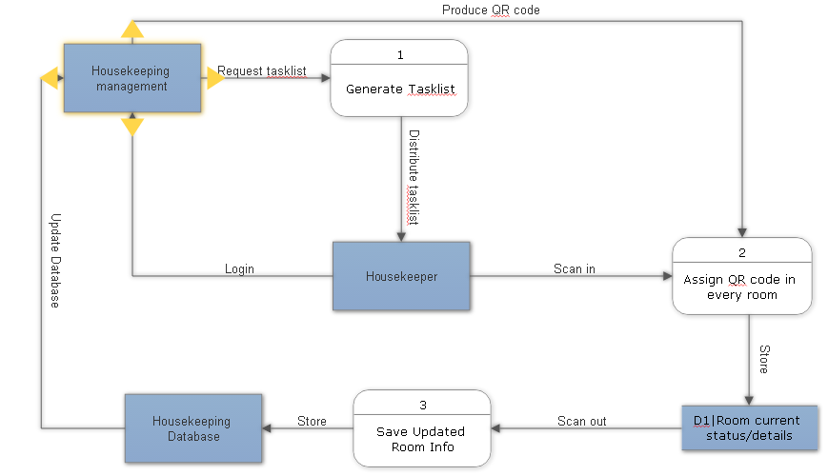

A data flow diagram (DFD) is a graphical representation of the "flow" of data through an information system, modelling its process aspects. ADFD is often used as a preliminary step to create an overview of the system without going into great detail, which can later be elaborated.

## **5.1.2 Data Dictionary**

### **Inspection**

|  |  |  |
| --- | --- | --- |
| **Inspection** | **Column Name** | **Column Type** |
|  | Inspection_Task | VARCHAR(45) |
|  | Inspection_Assignment | VARCHAR(45) |
|  | Inspection_TimeIn | DATETIME |
|  | Inspection_TimeOut | DATETIME |

### **Room Table**

|  |  |  |
| --- | --- | --- |
| **Room** | **Column Name** | **Column Type** |
|  | Room_ID | INT(3) |
|  | Room_Num | INT(3) |
|  | Room_type | VARCHAR(60) |
|  | Room_status | VARCHAR(20) |

### **Cleaning**

|  |  |  |
| --- | --- | --- |
| **Cleaning** | **Column Name** | **Column Type** |
|  | Checklist_ID | INT(3) |
|  | Checklist_Taskname | VARCHAR(45) |
|  | Checklist_TaskDesc | VARCHAR(120) |
|  | Checklist_Status | VARCHAR(45) |

### **Checklist**

|  |  |  |
| --- | --- | --- |
| **Checklist** | **Column Name** | **Column Type** |
|  | Checklist_ID | INT(3) |
|  | Checklist_Taskname | VARCHAR(45) |
|  | Checklist_TaskDesc | VARCHAR(120) |
|  | Checklist_Status | VARCHAR(45) |

### **Employee**

|  |  |  |
| --- | --- | --- |
| **Employee** | **Column Name** | **Column Type** |
|  | Employee_ID | INT(3) |
|  | Employee_Fname | VARCHAR(45) |
|  | Employee_Lname | VARCHAR(45) |
|  | Employee_MI | VARCHAR(3) |
|  | Employee_Department | VARCHAR(100) |
|  | Employee_Position | VARCHAR(60) |
|  | Employee_Attendance | VARCHAR(45) |

|  |  |
| --- | --- |
| **Name** | **Description** |
| **Ancillary** | Providing support to the primary activities or operation of an organization, institution or system. |
| **Byte code** | Computer object code that is processed by a program, usually referred to as a virtual machine, rather than by the "real" computer machine, the hardware processor |
| **Circular buffer queueing** | a data structure that uses a single, fixed-size buffer as if it were connected end-to-end |
| **Grid Computing** | The collection of computer resources from multiple locations to reach a common goal? |
| **Java Virtual Machine** | Is an abstract computing machine that enables a computer to run a Java program |
| **Module** | A module is a separate unit of software or hardware. Typical characteristics of modular components include portability, which allows them to be used in a variety of systems |
| **Monolithic systems** | A [software system](https://en.wikipedia.org/wiki/Software_system) is called "monolithic" if it has a monolithicarchitecture, in which functionally distinguishable aspects |
| **User-friendly interface** | Refers to anything that makes it easier for novices to use a computer. |
| **Streamline** | To make (an organization or system) more efficient and effective by employing faster or simpler working methods. |
| **SM Hotels** | SM Supermalls, owned by [SM Prime Holdings](https://en.wikipedia.org/wiki/SM_Prime_Holdings), is a chain of shopping malls in the [Philippines](https://en.wikipedia.org/wiki/Philippines) that has 62 malls located across the country and 6 in [China](https://en.wikipedia.org/wiki/China). |

**5.1.3 Tables/Files Layout**

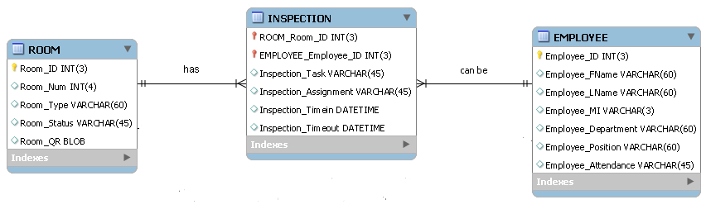

An employee can be an Inspector/Supervisor. An employee is assigned to many rooms and will be given some tasks in each room. The time-in and time-out will also be recorded to the system.

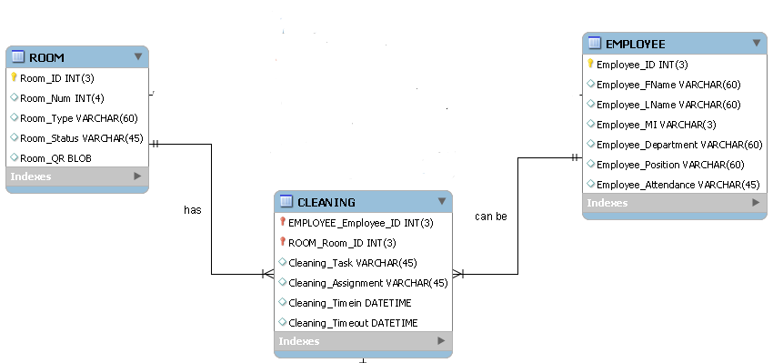

An employee can be the Housekeeper which is mainly doing the cleaning part in each hotel room. A Housekeeper is assigned to many rooms and will do the housekeeping tasks in each room he/she is assigned to. The time-in and time-out will be recorded for the tracking of the housekeeper’s productivity level.

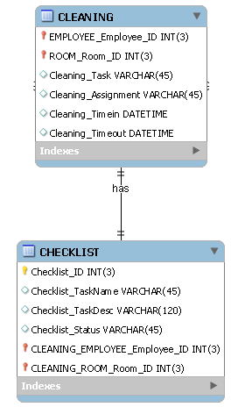

A housekeeper has a checklist that he/she needs to do in each room that he/she is assigned to. A checklist has all the complete list of tasks that a housekeeper must do.

* 1. **Other Diagrams**
     1. **Proposed Conceptual Framework**

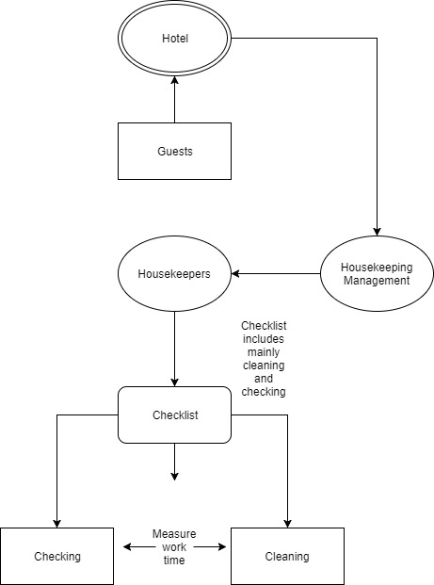

**5.3.3 Use Case Diagram**

## **C:\Users\famador\Desktop\New use case\Use Case(Revised).jpgUse Case Diagram**

\

A use case diagram is a graphic depiction of the interactions among the elements of a system. A use case is a methodology used in system analysis to identify, clarify, and organize system requirements. The use cases, which are the specific roles played by the actors within and around the system

## **5.4.1 Use Case Narative Report**

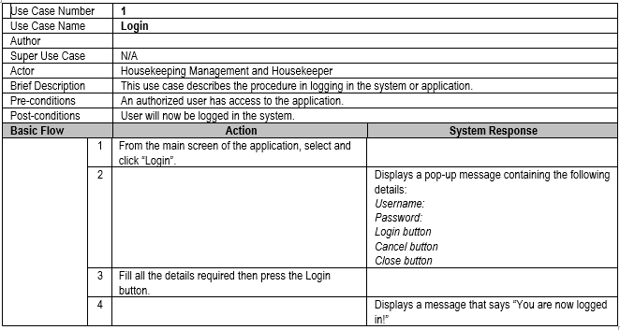

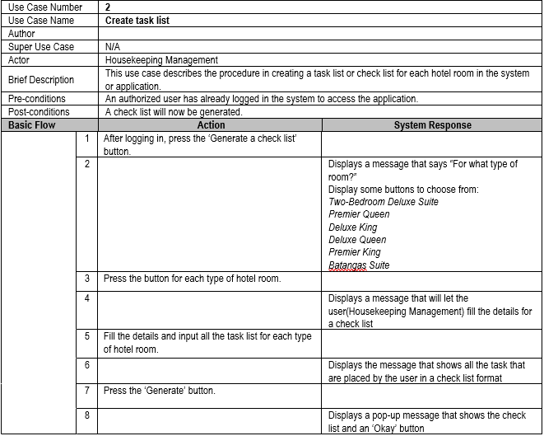

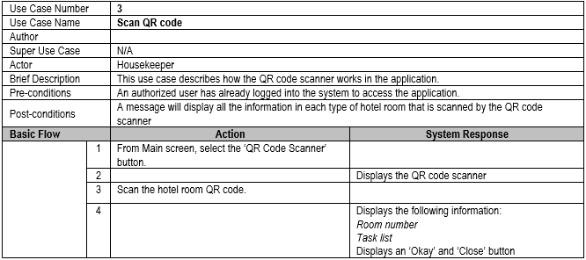

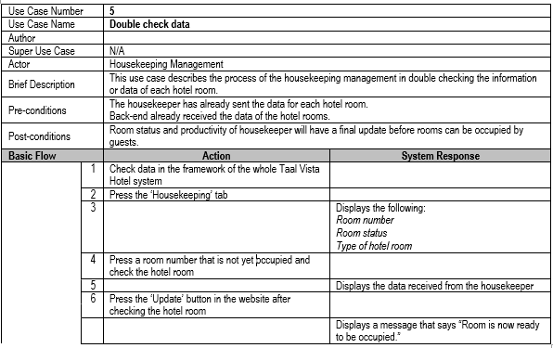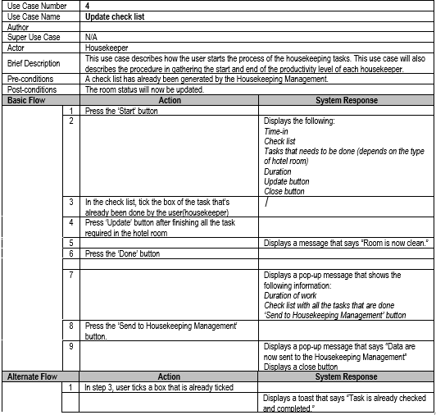

## **5.4.2 Activity Diagram**

**Activity diagram** is a diagram that is part of a **UML.** It describes the dynamic aspects of the system. Activity diagram is basically a flowchart to represent the flow from one activity to another activity.

**Room Cleaning Module**

### **5.4.2.1 Login**

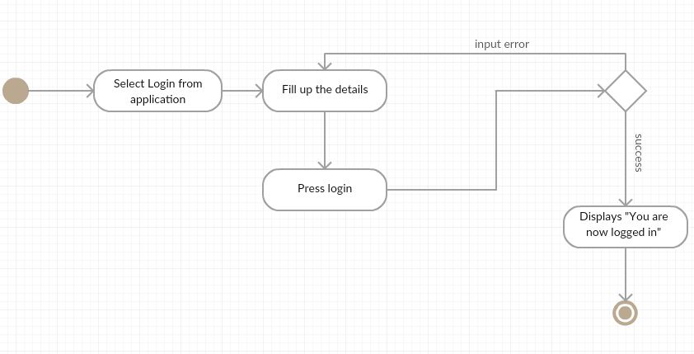

### **5.4.2.2 Create Task list**

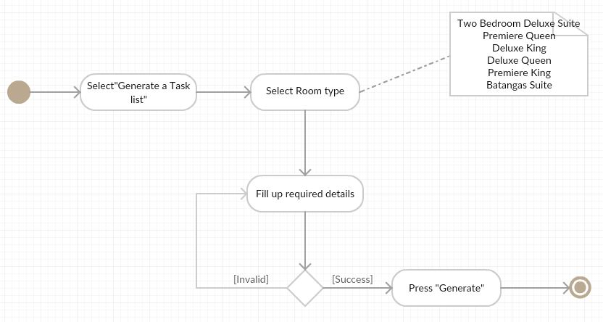

### **5.4.2.3 Scan QR code**

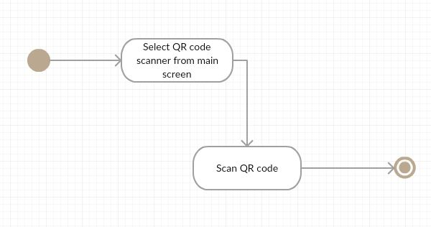

### **5.4.2.4 Update Checklist**

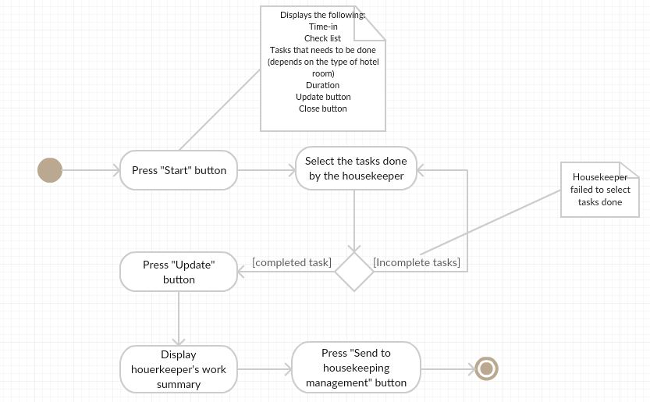

### **5.4.2.5Double Check Data**

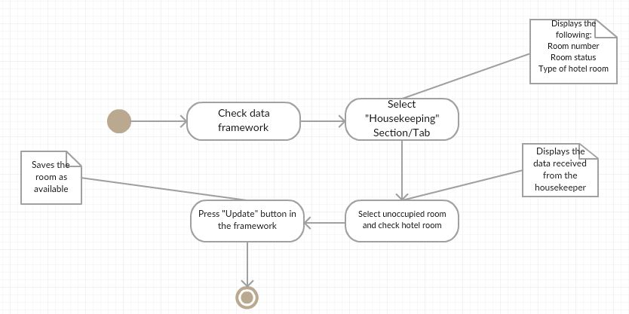

# **Methodology, Results and Discussion**

## **5.4 Entity Relationship Diagram**

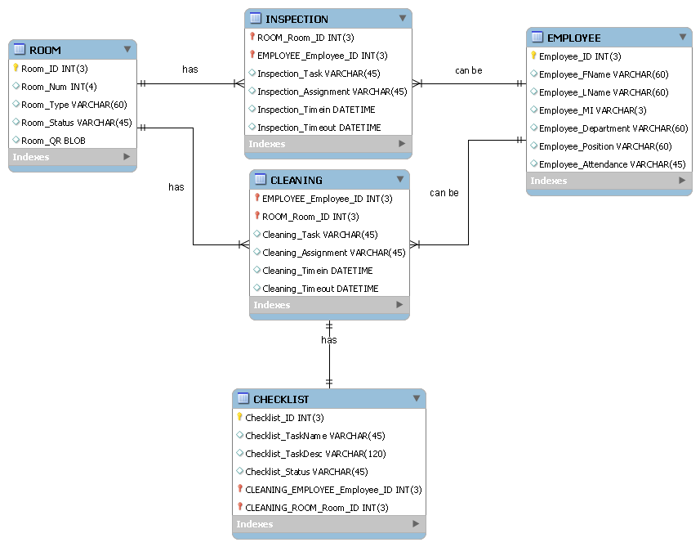

**Description:**

The system's database includes 5 tables: ROOM, EMPLOYEE, INSPECTION, CLEANING, CHECKLIST. In each hotel room, there can be many employees working on it but in a different assignment. Each employee can also work on many rooms in which the database creates a bridge called the ‘INSPECTION’ and the ‘CLEANING’ tables. The INSPECTION table includes the task in which the employee is assigned to. In the CLEANING table, there is also a task attribute and the assignment attribute for each employee. The CLEANING table also has a relationship with the CHECKLIST table. In each cleaning process, there will be a checklist that needs to be finished by the employee in the CLEANING position.

**5.4.1 Tables/Files Layout**

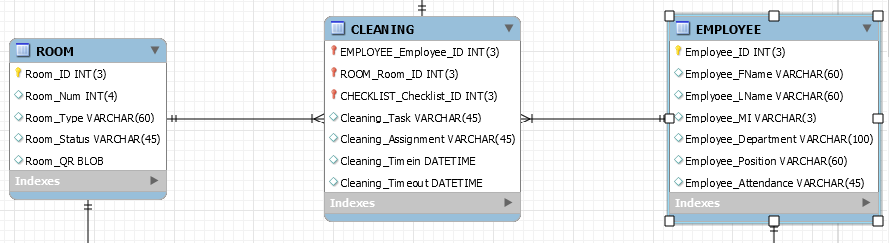

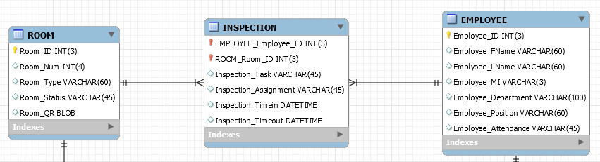

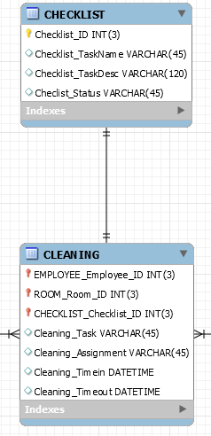

## **5.5.5 Gap Analysis**

|  |  |  |  |
| --- | --- | --- | --- |
| Hotel Room Cleaning Module | | | |
| **User Requirements** | **Current System** | **Proposed Changes** | **Remarks / Impact** |
| 1. Maintaining the room clean. | Checking each room for daily room maintenance. | By using the Hotel Room Cleaning module, management would be able to record the prepared room for the guests. | To keep updated real time. |
| 2. Housekeepers should login in the system’s application | Manually keeping logs of housekeeper and staffs attendance. | Unity housekeeping system will require every staff and housekeepers to have a personal username and password. | To keep track of each housekeeper and staffs productivity. |
| 3. The management can generate tasks for housekeepers through the application | The housekeeping management manually distributes tasks to housekeepers | The tasks distributed to housekeepers is updated. | Housekeepers productivity will be reported through the database easily. |

## **5.5.6 Gantt Chart**

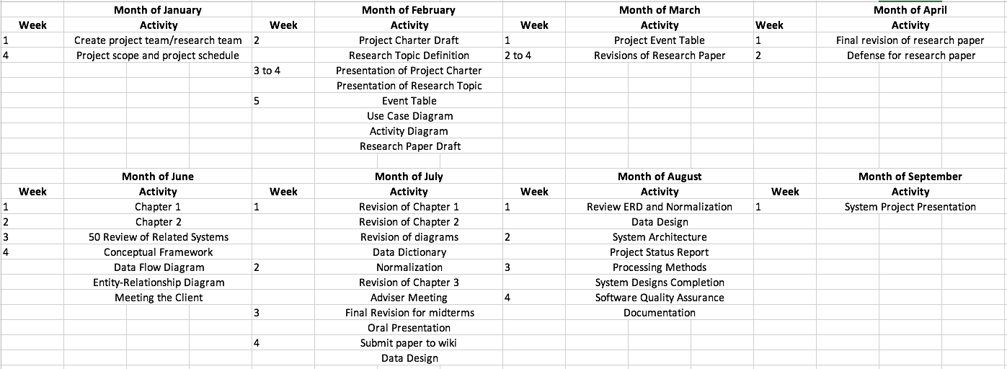

# **6.0 Bibliography**

B, B. (2000). *Property Management Simplified*. Retrieved from Hotelogix: http://www.hotelogix.com/

Balagosa. (2008). *Jinisys Housekeeping*. Retrieved from JInisys: http://jinisyssoftware.com/products/

*Carter Casino*. (2016). Retrieved from http://cartercasino.com/hotel/rates-and-information

*Ciircus*. (2017). Retrieved from https://www.ciirus.com/about-us.aspx

Connerly, C. (2003). *Living Learning in Community*. Retrieved from http://legacy.earlham.edu/~kohlhe/blog/archives/000768.html

Crig. (2005). *Factory Systems*. Retrieved from factory systems: https://www.factorysystems.eu/index-en.php?id=5s-en

Dehan J, D. W. (n.d.).

Dehan J, D. W. (2015). *Maestro*. Retrieved from http://www.maestropms.com/?q=press-release/maestro-pms-users%E2%80%99-conference-2015-ah-ha-moments-everyone

Divina. (2015). *Momvoyage*. Retrieved from http://momvoyage.hilton.com/about-us

*Djumbo*. (2015). Retrieved from http://www.littlehotelier.com/

*Elina Hotel*. (2011). Retrieved from http://www.elinahotel.gr/default.aspx?langid=2

*Fairmont Hotel Housekeeping*. (1999). Retrieved from Fairmont: http://www.fairmont.com/

Granholm. (2011). *HIBOX Housekeeping*. Retrieved from Hibox: http://www.hibox.tv/index.shtml

*GuestPoint*. (2016). Retrieved from http://www.guestpoint.com/

*HHS Housekeeping*. (1975). Retrieved from https://www.hhs1.com/

Hohman, R. (2007). *Starwood Hotel & Resorts*. Retrieved from Starwood: https://www.glassdoor.com/Hourly-Pay/Starwood-Hotels-and-Resorts-Housekeeping-Hourly-Pay-E335_D_KO28,40.htm

*Hotel Housekeeping Inspection Software*. (2006). Retrieved from inspect2go: http://inspect2go.com/hotels/housekeeping-software

*Hotel Management System*. (2006). Retrieved from Trigernix: https://www.tigernix.com/home/software/hotel-management-system

*Hotello*. (2017). Retrieved from http://mingus-software.com/en/hotello/

*Janiking*. (2017). Retrieved from https://www.janiking.com/commercial-cleaning-services/hotel-and-resort-housekeeping/

Khaled. (2010). *Room Key PMS*. Retrieved from Room Key PMS: http://support.roomkeypms.com/

*Little Hotelier*. (2006). Retrieved from http://www.littlehotelier.com/

McLean. (1993). *acgil*. Retrieved from http://www.acgil.com/products/smart_deals.htm

McLean. (n.d.). *acgil*.

Midjili. (2012). *Mobile Operation Platform*. Retrieved from http://www.lodgingcontrols.com/

Midjili. (n.d.). *Mobile Operation Platform*. Retrieved from http://www.lodgingcontrols.com/

*Modern Housekeeping* . (2008). Retrieved from FCSCS: https://www.fcscs.com/e-housekeeping/?gclid=Cj0KCQjw7pHLBRDqARIsAFyKPa6JKWDnUgIUx_L7fGi-sl5hsjthBc1HZBWKNET6DOtMFbfj5nAOMgIaAhLxEALw_wcB

*Online Hotel Property Management System*. (2009). Retrieved from Snap PMS: http://www.snappms.com/

*Payscale*. (2017). Retrieved from http://www.payscale.com

*Peek Housekeeping*. (2015). Retrieved from https://peekpro.com/booknow

*Prologic Housekeeping*. (2012). Retrieved from Prologic: http://www.prologicfirst.com/news/Hotel-Software-for-Smartphones.html

*Protel Housekeeping*. (2017). Retrieved from http://www.protel.net/

*Resort Data Processing*. (1998). Retrieved from RDP: http://www.resortdata.com/

Ridge. (2012). *Housekeeping Schedules*. Retrieved from Home Sanctuary: http://www.homesanctuary.com/rachelanne/2011/09/housekeeping-schedules-and-daily-home-management.html

*RoomMaster*. (2017). Retrieved from http://roommasterpms.co.uk/

*Silk Hospitality*. (1998). Retrieved from http://www.silkhospitality.com.au/why-outsource-housekeeping-services

*SmartButler*. (1989). Retrieved from http://jaybee.com/

*SMS Service Management*. (2009). Retrieved from Service Management: https://www.fieldaware.com/

*The Optimum Housekeeping Solution*. (2011, July). Retrieved from Optii Keeper: http://optiisolutions.com/

Thompson. (2011). *Grandmeneng*. Retrieved from http://www.grandmeneng.com

*Waterfront*. (1995). Retrieved from Waterfront Hotels: http://www.waterfronthotels.com.ph/

*WebRezPro*. (2003). Retrieved from https://www.webrezpro.com/

Winterhalter. (1947). *Winterhalter housekeeping*. Retrieved from winterhalter: http://www.winterhalter.biz/

*World Hotels*. (n.d.). Retrieved from http://www.payscale.com

*World Hotels*. (2017). Retrieved from http://www.payscale.com

*Xotelia*. (2015). Retrieved from https://www.xotelia.com/